HAND GUNS

standard issue Pistolet Makarova (PM), made in Russia
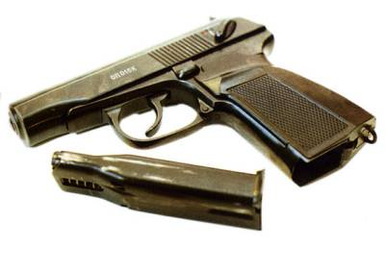

PB / 6P9 silenced pistol (USSR / Russia)

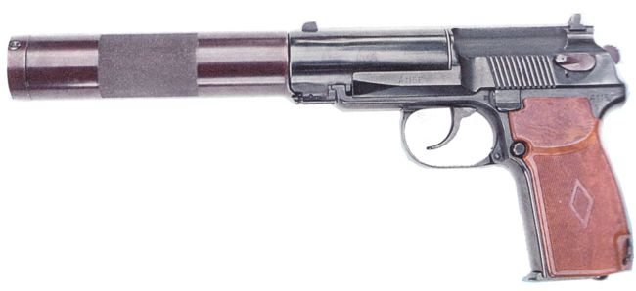

Yarygin PYa / MP-443 "Grach" pistol (Russia)
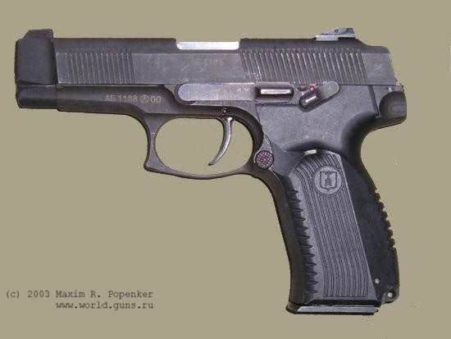

SUB MACHINE GUNS

Degtyarov PPD-40 submachine gun (USSR)
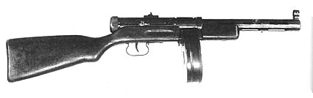

Kedr / Klin submachine gun (Russia)
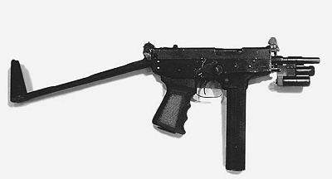

AEK-919 K "Kashtan" (Russia)
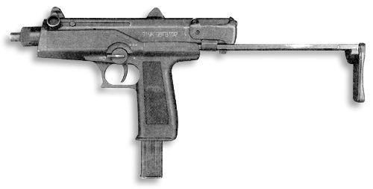
ASSAULT RIFLES

Kalashnikov AK-47 and AKM assault rifles (USSR)
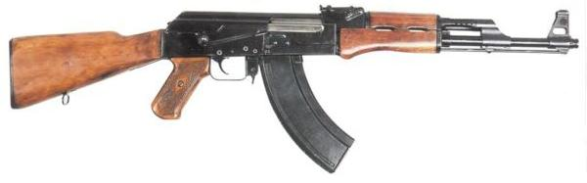

Nikonov AN-94 "Abakan" assault rifle (Russia)
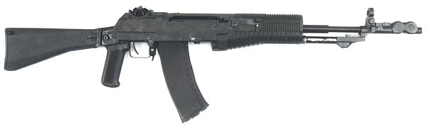

AEK-971 (Russia)
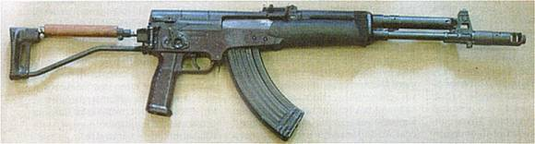

SNIPER RIFLES

VSSK Vychlop ("Exhaust") silenced sniper rifle (Russia)
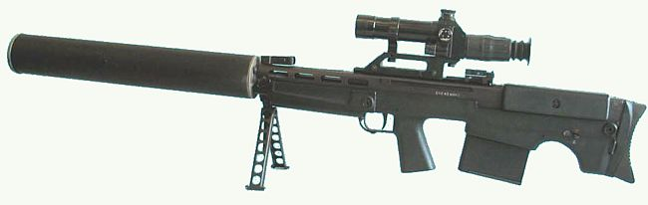

SVN-98 (expiremental model) (Russia)
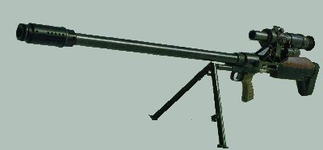

SV-98 sniper rifle (Russia)
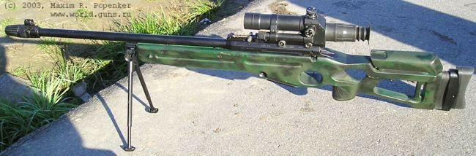

MACHINE GUNS

Degtyarev DP DPM RP-46 (Russia / USSR)
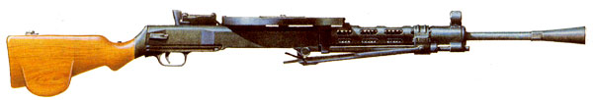

Kalashnikov PK / PKS / PKM / PKMS machinegun (USSR/Russia)
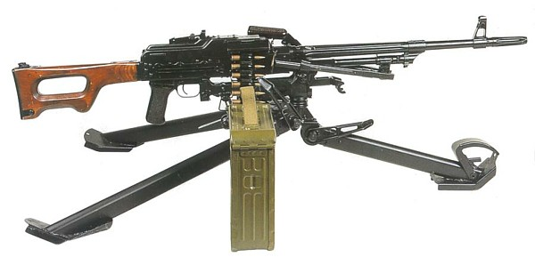

Pecheneg (Russia)
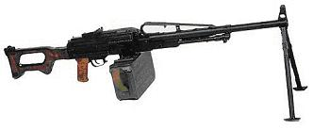
SHOTGUNS

TOZ-194 (Russia)
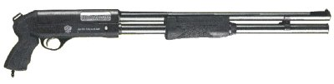

Saiga 12 (Russia)
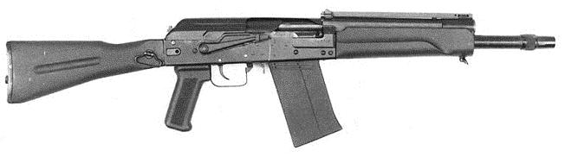

RMB-93 (Russia)
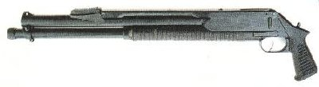
POSSIBLE ARMORS

Pabite Cloak 50 credits
Quicksilver 250 credits
Trenchcoat 500 credits
Shumi Vest 1,000 credits
Chain Mail 2,000 credits
Powersoul 4,000 credits
Light Kevlar Vest 10,000 credits
Astral Shield 20,000 credits
Titanium Armor 30,000 credits
Escort Guard 40,000 credits
Heavy Kevlar Vest 60,000 credits
Dragonlance 85,000 credits
Electro-Magnetic Shield 100,000 credits
Guardian Robe 200,000 credits
Plasma Shield 300,000 credits
Mystile 400,000 credits
Matrix Shield 500,000 credits
Shadowfax 600,000 credits
Pseudo 700,000

